Advance java lab

Write a java program to create two threads (which run in parallel), so that one thread prints 1 to 10 and another thread prints 10 to 1 in reverse.

**package** advjava;

//creating ascending class to run forward

**class** ascending **extends** Thread{

**public** **void** run(){

**for**(**int** i=1;i<11;i++)

System.***out***.println(i);

}

}

// creating descending class to run reverse

**class** descending **extends** Thread{

**public** **void** run(){

**for**(**int** i=10;i>0;i--)

System.***out***.println(i);

}

}

**public** **class** Multi_thread {

**public** **static** **void** main(String[] args) {

// **TODO** Auto-generated method stub

ascending asc=**new** ascending();//creating object for ascending class

descending dsc=**new** descending();//creating object for descending class

asc.start();

dsc.start();

}

}

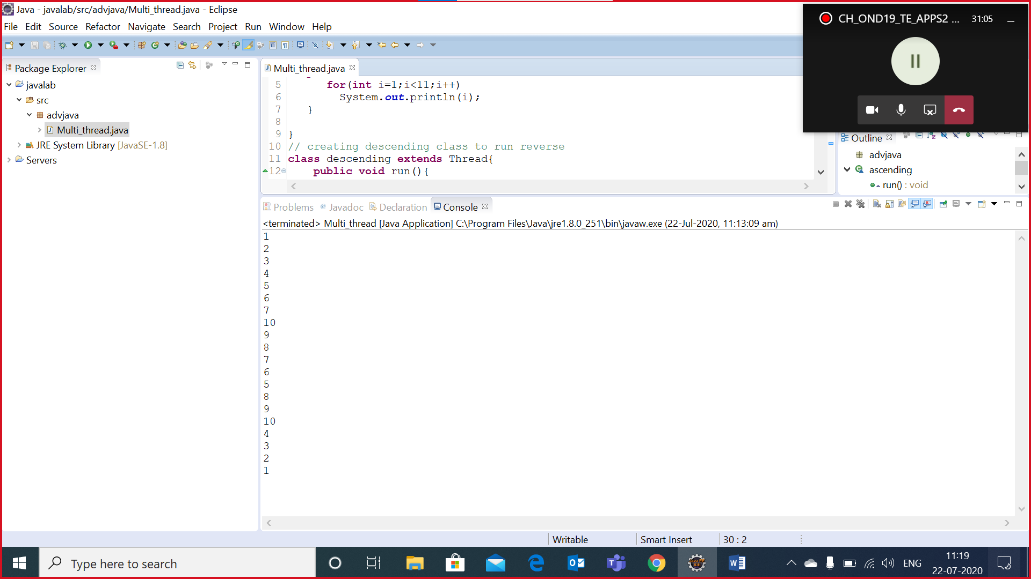

Create a class Student with attributes { RegNo, Name, Phone, Course }.  
In main method create five objects for Student and add it to ArrayList.  
Using a loop (preferably enhanced for loop), try to print all the student information.

package arraylist;

import java.util.ArrayList;

import advjava.Student;

class Student{

int regno;

String name;

long phone;

String course;

@Override

public String toString() {

return "Student [regno=" + regno + ", name=" + name + ", phone=" + phone + ", course=" + course + "]";

}

public int getRegno() {

return regno;

}

public void setRegno(int regno) {

this.regno = regno;

}

public String getName() {

return name;

}

public void setName(String name) {

this.name = name;

}

public long getPhone() {

return phone;

}

public void setPhone(long phone) {

this.phone = phone;

}

public String getCourse() {

return course;

}

public void setCourse(String course) {

this.course = course;

}

public Student(String name) {

super();

this.regno = regno;

this.name = name;

this.phone = phone;

this.course = course;

}

public class Array {

public void main(String[] args) {

// TODO Auto-generated method stub

Student std=new Student("123,viswa,9025678943,java");

Student std1=new Student("124,balaji,9025678564,HTML");

Student std2=new Student("125,guru,9025678967,dbms");

Student std3=new Student("126,kanish,9025678998,bca");

Student std4=new Student("127,ajith,9025678912,phython");

ArrayList<Student> arr=new ArrayList();

arr.add(std);

arr.add(std1);

arr.add(std2);

arr.add(std3);

arr.add(std4);

for( Student arr1: arr){

System.out.println((arr1));

}

}

}

}

Develop a web application through which the end user should be able to store the below information of a user in oracle/mysql database.  
   a) Name  
   b) Aadhar ID  
   c) City  
   d) State  
   e) Pincode  
   f) Number of dependents

Html page:

<!DOCTYPE html>

<html>

<head>

<meta charset=*"ISO-8859-1"*>

<title>Insert title here</title>

</head>

<body>

<form action=*"LoginServlet"* method=*"post"*>

<h1 allign=*"centre"*>APPLICATION FORM</h1>

<table>

<tr>

<td>name</td>

<td><input type=*"text"* name=*"name"*></td>

</tr>

<tr>

<td>Aadhar id</td>

<td><input type=*"number"* name=*"Aadid"*></td>

</tr>

<tr>

<td>city</td>

<td><input type=*"text"* name=*"city"*></td>

</tr>

<tr>

<td>state</td>

<td><input type=*"text"* name=*"state"*></td>

</tr>

<tr>

<td>pincode</td>

<td><input type=*"number"* name=*"pin"*></td>

</tr>

<tr>

<td>no of dependents</td>

<td><input type=*"number"* name=*"nod"*></td>

</tr>

</table>

<input type=*"submit"* name=*"submit"*>

</form>

</body>

</html>

Servlet page

**package** loginpage;

**import** java.io.IOException;

**import** java.io.PrintWriter;

**import** java.sql.Connection;

**import** java.sql.DriverManager;

**import** java.sql.PreparedStatement;

**import** java.sql.ResultSet;

**import** javax.servlet.ServletException;

**import** javax.servlet.annotation.WebServlet;

**import** javax.servlet.http.HttpServlet;

**import** javax.servlet.http.HttpServletRequest;

**import** javax.servlet.http.HttpServletResponse;

/**

* Servlet implementation class LoginServlet

*/

@WebServlet("/LoginServlet")

**public** **class** LoginServlet **extends** HttpServlet {

**private** **static** **final** **long** ***serialVersionUID*** = 1L;

/**

* **@see** HttpServlet#HttpServlet()

*/

**public** LoginServlet() {

**super**();

// **TODO** Auto-generated constructor stub

}

/**

* **@see** HttpServlet#doGet(HttpServletRequest request, HttpServletResponse response)

*/

**protected** **void** doGet(HttpServletRequest request, HttpServletResponse response) **throws** ServletException, IOException {

// **TODO** Auto-generated method stub

response.getWriter().append("Served at: ").append(request.getContextPath());

}

/**

* **@see** HttpServlet#doPost(HttpServletRequest request, HttpServletResponse response)

*/

**protected** **void** doPost(HttpServletRequest request, HttpServletResponse response) **throws** ServletException, IOException {

//creating printwriter

PrintWriter out=response.getWriter();

String name=request.getParameter("name");

**long** Aadharid=Long.*parseLong*(request.getParameter("Aadid"));

String city=request.getParameter("city");

String state=request.getParameter("state");

**long** pincode=Long.*parseLong*(request.getParameter("pin"));

**long** noofdependencies=Long.*parseLong*(request.getParameter("nod"));

out.println("values got");

Connection con=**null**;

PreparedStatement pt=**null**;

**try**{//connecting to the sql

Class.*forName*("oracle.jdbc.driver.OracleDriver");

con=DriverManager.*getConnection*("jdbc:oracle:thin:@Desktop-PAONS72:1521:xe","system","system");

out.println("connected");

// set information into the table

String information="insert into information values(?,?,?,?,?,?)";

pt=con.prepareStatement(information);

pt.setString(1, name);

pt.setLong(2, Aadharid);

pt.setString(3, city);

pt.setString(4, state);

pt.setLong(2, pincode);

pt.setLong(2, noofdependencies);

ResultSet rs=pt.executeQuery();

**if**(rs!=**null**)

out.println("values inserted");

}

**catch**(Exception e){

e.printStackTrace();

}

}

}

